Transition Research
Good Practice
Original Document: Bromley Toolkit for Effective Transition
Is there are a named strategic lead for transition in your school and a group of key staff who are effectively part of the transition ‘team’ (this should include you)?
Do you have systems in place to ensure that feeder settings/providers are not being asked to provide the same information more than once?
Is clear information (i.e. in plain English) provided to parents/carers about your school’s transition policy and arrangements?
Is specific funding allocated to implementing effective transition, e.g. linked with the SEN notional budget and the Pupil Premium Grant?
Are there clear, robust systems within your school to ensure that all key information is shared between you and other the other staff involved in transition, including staff who oversee pastoral and safeguarding aspects?

Original Document: Oxford EY Transition Pack
Key principles for good practice in supporting successful early years transitions
Unique Child
• Recognise that all children, can be vulnerable at times of change, particularly those with additional needs e.g. those with a Special Educational Need (SEN) or a child in care. Planning for these children will need additional, flexible support.
• Prepare the child for change. It is important that all children experience a positive transition. With appropriate preparation and understanding, children are more likely to feel secure and settle more easily into their new environment. It is here that the Early Years Summary/Transfer Form can act as a supportive tool within the transition process.
Positive Relationships
• Transitions can be eased by careful proactive planning, sharing of information and mutual visiting between parents, carers and professionals.
• Listen to and acknowledge the important role of parents and carers throughout this process
• Work together. An essential element of an effective transition is for childminders, settings and schools to work together, to establish a clear understanding of one another’s aims, purpose and philosophy.
• Sign post families to health services e.g. Health visiting and School health nursing
• Offer a range of opportunities for parents/carers to access information about the transition process, e.g. open days, information events, consultations, newsletters.
Enabling Environments
• Children cope better with transitions when conditions are similar, communication is encouraged, and the process of change takes place gradually over time
• The emotions that come with change can be successfully handled by children when their new setting/school has a clear, welcoming procedure.

Children learn and develop in different ways and at different rates
• Ensure that consideration is given to the child’s holistic needs. It is important to ensure that the continuity of children’s experiences involves all aspects of their care and learning

Original Document: Children First Northamptonshire
Children should be at the heart of all transition arrangements. Providing a quality transition process should not be underestimated for the impact it can have on a child’s future learning and development as they move on to school. Transitions should be considered as a continuous and evolving process adapted to meet the needs of the individual child and their families, not a one off event and therefore, the Transition Document should be completed as part of this process.
It is crucial that all professionals involved commit to partnership working and build strong relationships that foster positive communication and support smooth transitions. Early years providers, schools, parents and other professional agencies all have a shared responsibility to ensure that every child is ready to continue their learning journey as they enter school. A child who feels secure during and after the move will be more likely to engage with their new environment in a positive way and access the learning opportunities more readily.
Central to a successful transition is the appropriate and timely sharing of information with consent. Sharing of information enables professionals to be better prepared to provide services that are responsive and coordinated around the needs of the individual child. Through effective partnerships, children, parents and schools should promote children’s readiness for school and a school’s readiness for children

Original Document: Transition from pre-school to primary school Bromley
Add some school uniform to your role play/dressing up area. It doesn’t have to be the right type for each school. Most children will need to wear a uniform for their new school. For some children wearing new/different clothes might be distressing. School uniform can often be stiff and labels can be scratchy. Giving children the opportunity to feel, touch, try on (if they want to) will help with familiarity and also support children’s independence in getting dressed. Dressing toys teddies etc.
Getting some book bags from local schools to encourage children to play ‘going to school’ and include road safety role play to encourage thinking about road safety in preparation for walking to school.
Visit the school with the child/group of children going to the school. Take a camera and allow the children to choose what they want to photograph.

Original Document: Transition resource I CAN
The Code of Practice is ‘anticipatory’ meaning that education settings should not wait until an issue is identified before they prepare for it. An early years setting or school should therefore find out whether a child has special education needs and disabilities (SEND) before the child arrives with them.

A local authority can monitor the success of its transition planning by reviewing how many children with identified SEND have been appropriately supported in their new setting. Data about school and early years exclusions is also
important in this evaluation.
The best preparation for a new cohort of children includes the early years practitioners and teachers understanding the cohort’s strengths and needs, as well as those of the individual children. Once this is known, it may be necessary for staff to access continuing professional development (CPD) or specialist support.

Original Document: Transitions Best Practice Dingleys Promise
Key Transition Best Practice Examples
-‘Speed dating’ style annual events organised by the local authority where early years settings and
schools meet to exchange information about transitioning children.
- Simple ‘about me’ documents to give to schools to understand who the children are and how to best support them.
-Agreed simple area statement about early years transitions that gives a simple overview and establishes what the local authority expect from settings and schools.
General EY SEND issues
- children with SEND become concentrated on small number of settings who do it well. This leads to stress in those settings and inability to take more children but does not push other settings to develop their skills and capacity to support effectively.
- belief that 1:1 is gold standard – lack of understanding of benefits of inclusion among families in particular. Often parent groups exchange information about what funding they get, with the assumption that more hours of 1:1 is better for the child. Need to break down that assumption.
- settings often say they can’t support a child unless they get 1:1 funding – this also needs to be broken down so that settings understand how to work inclusively to give children the best start in education rather than having an adult constantly with them.
- parental lack of trust in LA’s and belief that when they offer inclusion it is to cut costs.
- pressures on local authority leadership lead to lack of investment in early intervention – short term thinking. Need to prove medium term financial impact to show it is a financially sound way of working.
- children with SEND in mainstream often having needs met/ being kept safe but not being supported to thrive in early education. Need for more support and training on meaningful inclusive practice rather than simply on having the child in the room.

Recommendations
Establish common transition approach which is flexible but has clear boundaries and best practice. Should focus on establishing common expectations between settings, schools and parents. Should also focus on holistic school readiness (schools being “child ready” as oppose to children being “school ready”).
ACTION: LA to lead consultation with EY, schools and parents to agree simple local transition approach document.
2. Establish common documentation, agreed by schools and settings so that what is needed is handed over, and schools commit to using information coming from the settings. Some areas have done this – but a key issue was that where a format was agreed in the early years and that was working well, it did not translate to schools.
ACTION: LA to lead consultation with EY, schools and parents to understand key drivers and motivators for EY and schools, and encourage the development of practical transition documents that feed into the needs and skills of both settings, and are clear and understandable for parents.
3. Support and develop early years staff so that they feel confident and able to support children inclusively in the early years. This should enable them to:
- identify needs as soon as possible
- confidently and positively have conversations with families
- provide children with the best inclusive support to thrive
- reduce over-reliance on 1-1 support
- have confidence in their strategies when handing over to schools.
It is also vital to spread this good practice widely to avoid children with SEND becoming concentrated in a few settings, who then get overwhelmed.
ACTION: LA to ensure support and training is available for their EY settings in inclusive practice, to continually reinforce the expectation that all settings are inclusive. Commit to sharing examples of good practice and success stories with families and settings to show how inclusive practice benefits children. Spreading good practice could also support an ever improving widely accepted set of new norms for “ordinarily good”
4. Support EHCP processes in the early years so that for those children who will obviously need ongoing support, the extra funding can begin as early as possible – and make the greatest impact. The EHCP process should not start because a child is approaching school age, but rather because the child needs it. In the long term this will reduce costs in primary and secondary education, as high quality early intervention leads to better lifelong outcomes, and children who are less likely to need special education.
ACTION: LA to encourage EY settings to start the EHCP process as soon as it is clear that a child will need one for their education. Support should be given to providers wherever possible to identify which children should be in this cohort.

5. Local authorities must ensure there are clear guidelines about what should be ordinarily available, and support and training for settings to enable that to happen. Then for children with lower level needs on SEN support there must be a simple application process for extra funding that is not based on 1:1 support, but on inclusive practice.
ACTION: LA to use national best practice and consultation with EY settings to develop an OA document. This should be promoted to parents to that they understand what should be available for their children in mainstream provision, building parental demand for inclusion.

Good Form Examples
Original Document: Islington Transition Information
Good features: Transition action plan; passport number means that it is relevant and reviewed (could be done as review cycle); short term plan could possibly be filled in from Early Help? Agenda to support transition meeting gives clear focus; transition review form ensures transition is revisited (again link to Early Help)
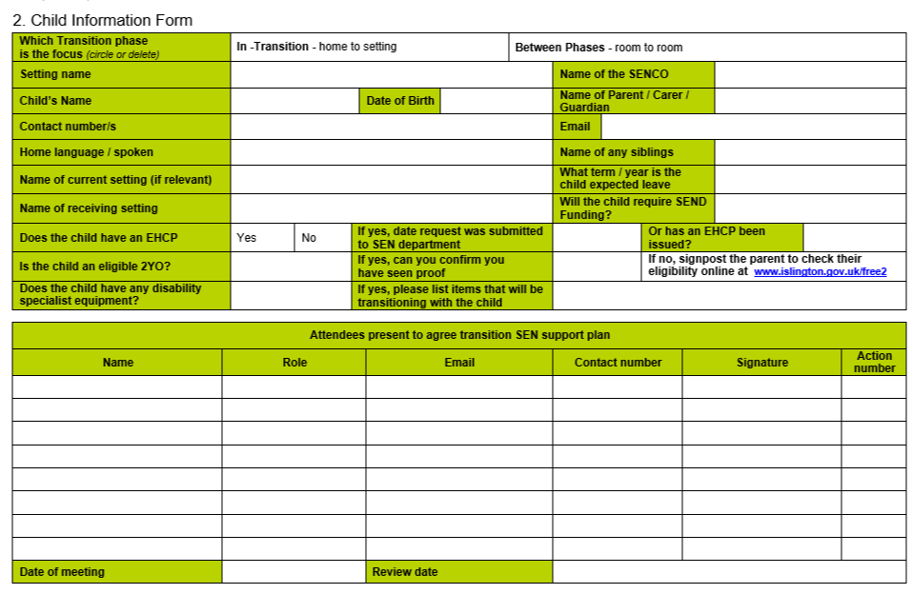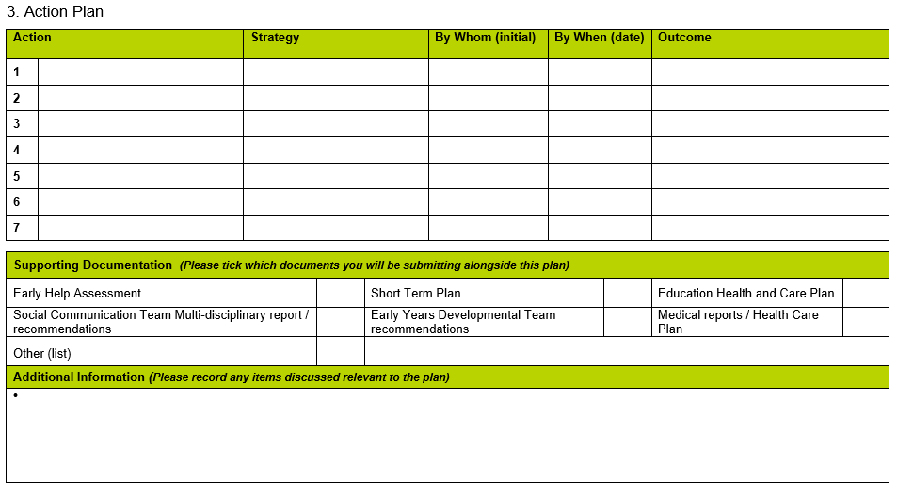

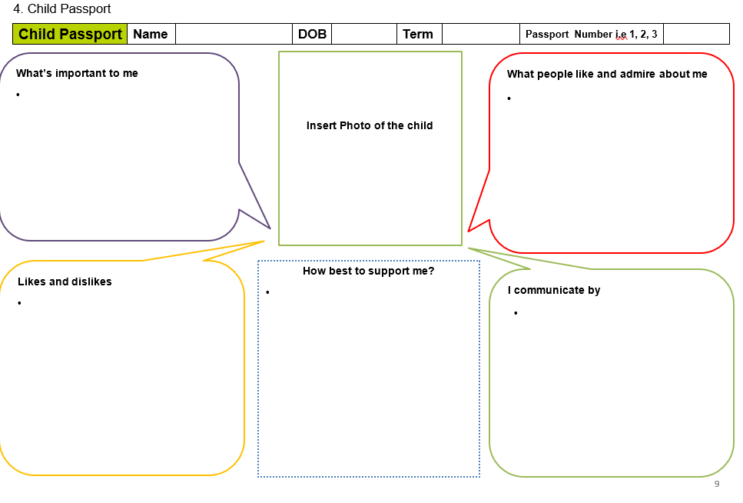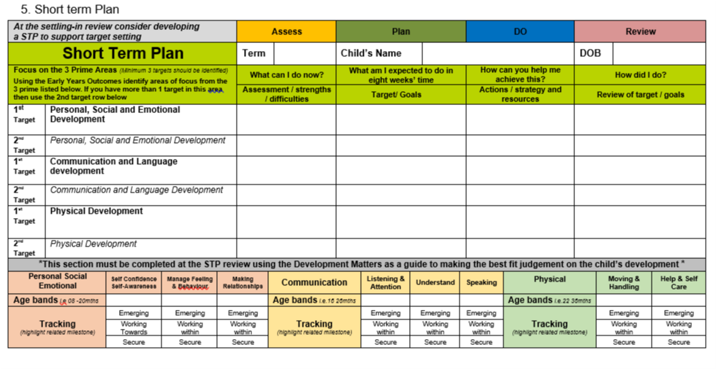

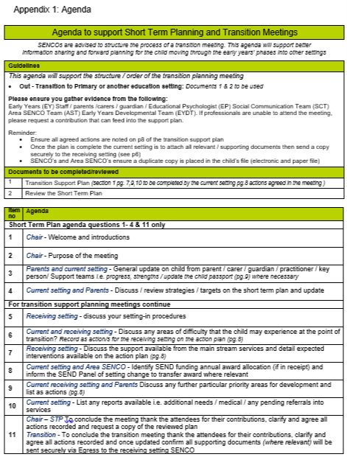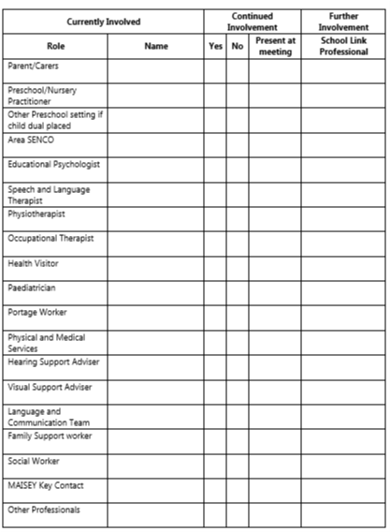

Original Document: Somerset County Council
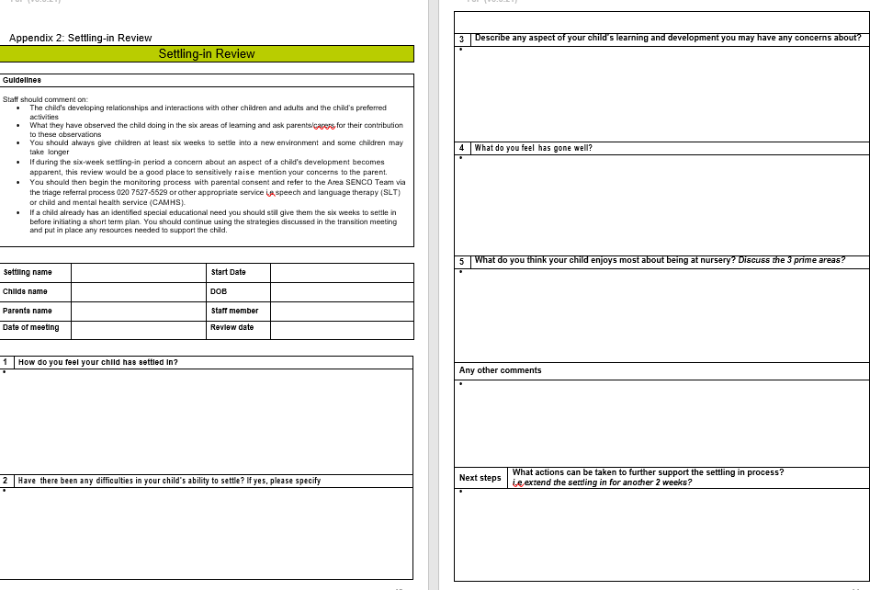
Good features: Clear identification of people involved/who needs to be involved; big box for strengths; Outcomes broken into clear actions; Review includes child view
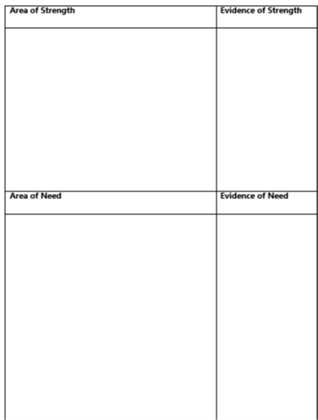
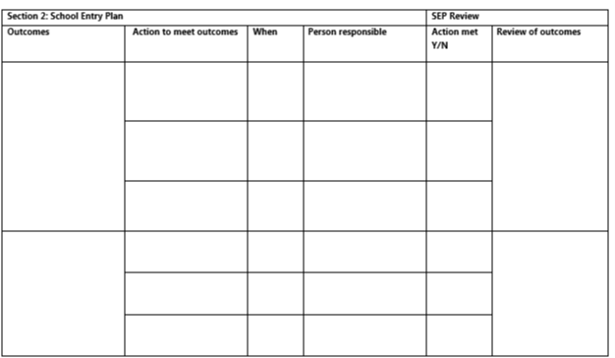

Original Document: Early Years Transition Form 1
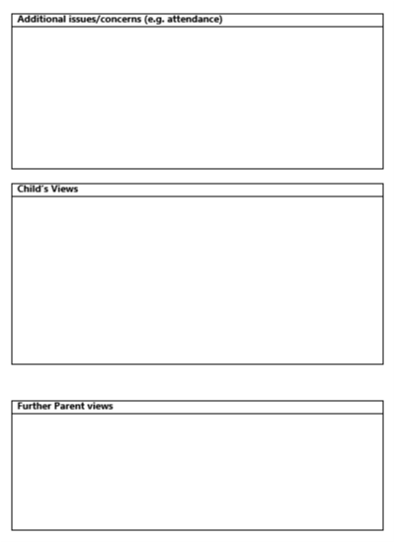
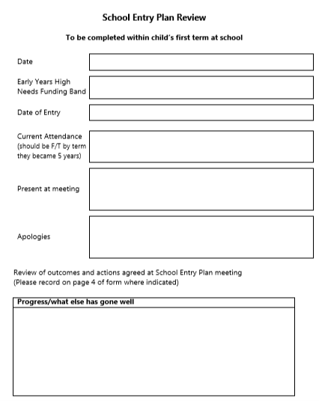
Good features: scaling level of support needed

Original Document: Transition Timeline for Children with SEND
Good features: Clear dates (feel they are a little late in the term though for SEN pupils considering school placements are announced in January)
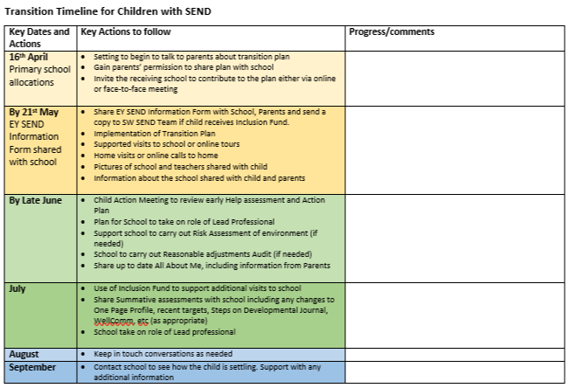
Original Document: Oxford EY Transition Pack
Good features: Supporting statements; Training needs for setting; My Culture Box on all about sheet; Communication Chart

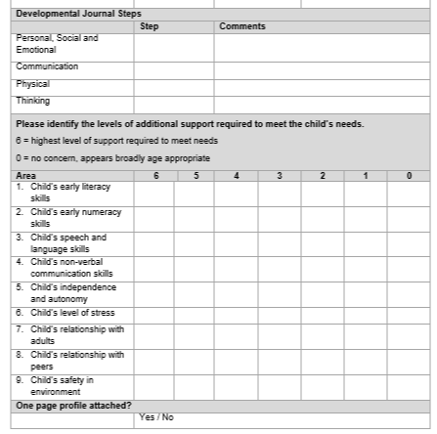
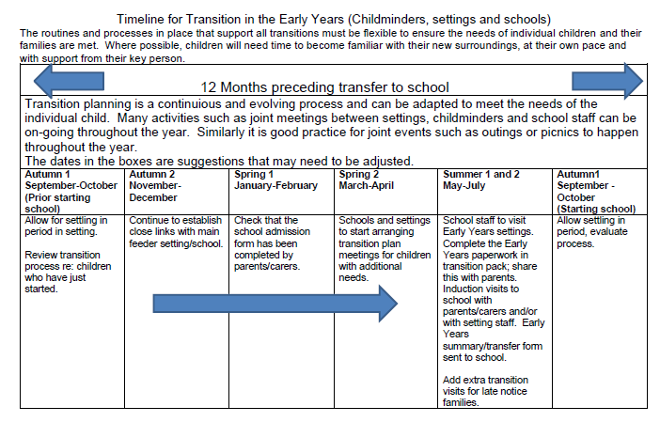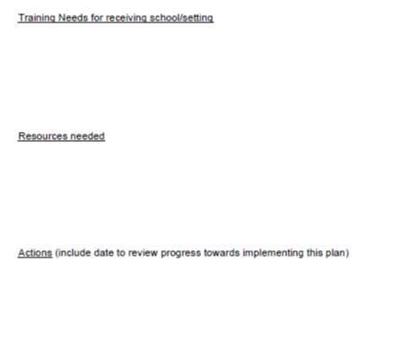
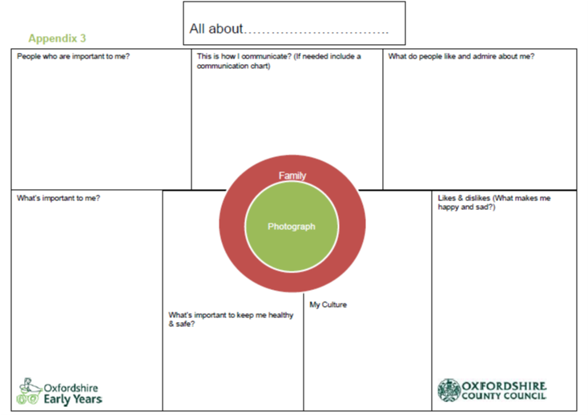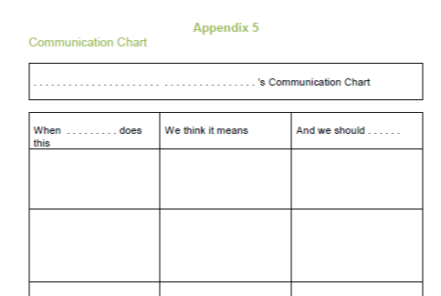

Original Document: Transition Liaison Guide
Good features: Timeline for nursery and FS2 transition; transition audit
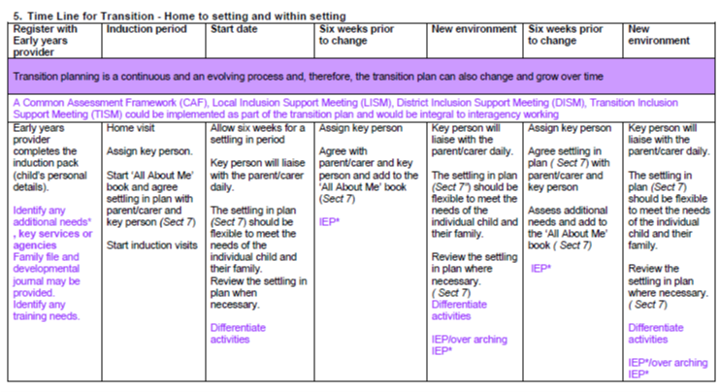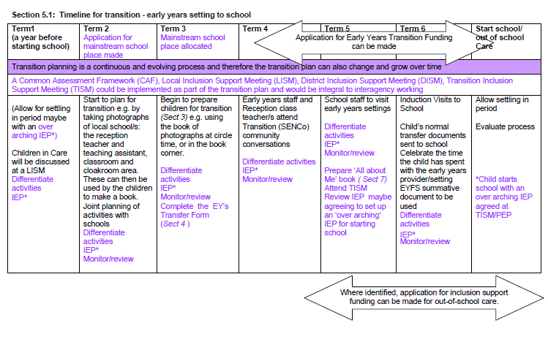

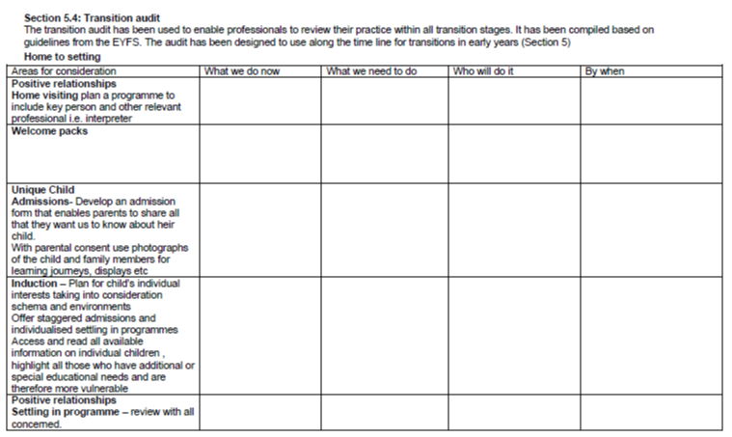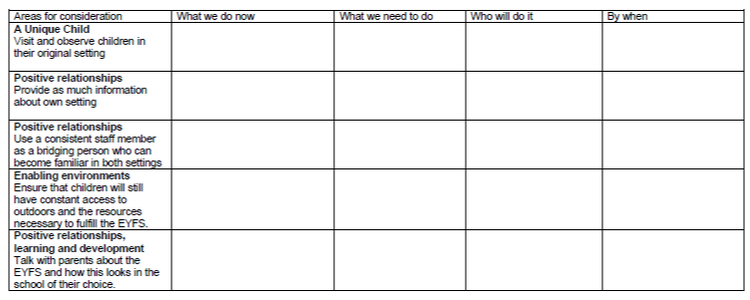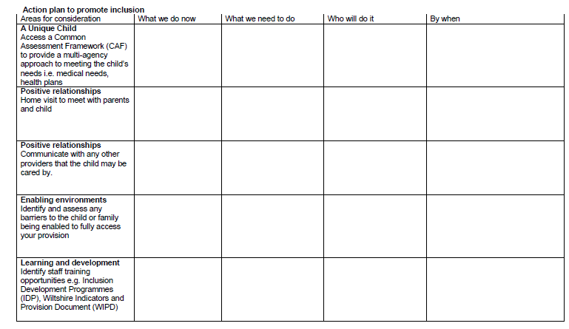

Original Document: Transition Paperwork
Good features: Action plan: Focus on Childs Strengths
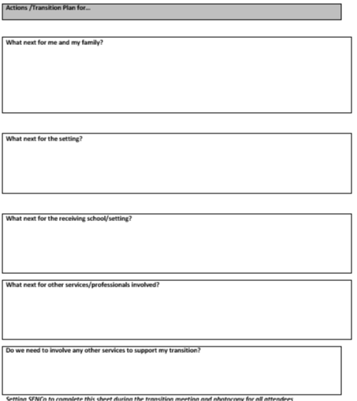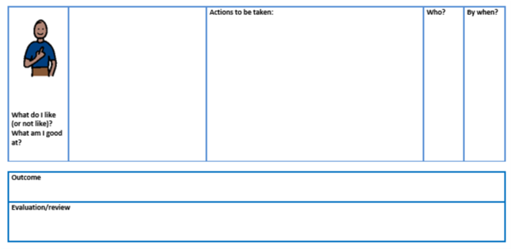

Supporting Information
Kruglanski first described a ‘need for closure’v as a means to resolve painful feelings created by a loss. We know that there are differences between individuals and how much they ‘need’ closurevi, but we also know that when under stress (e.g. following terrorist activity), there is an increased need for closure for everyonevii. We could anticipate that for some students, the anxiety elicited by school-closure may have increased the need to find closure on their school experience, whilst also denying the usual means to achieve it.
Psychology gives us some direction about how to approach this issue. Peak-end theoryviii describes a cognitive bias in our memory formation. This theory suggests that our positive or negative memory of an experience is dependant on the feelings at the extreme (peak) points and how the experience ends, rather than the average of the ‘whole’ experience. This affords us the opportunity to give an ending to the school experience which may impact on a student’s perception of both the school-closures and their whole school experience. Research also suggests that a ‘well rounded’ ending is associated with positive feelings about an event, reduced regret about an experience and an easier transition to the subsequent life phaseix.

