
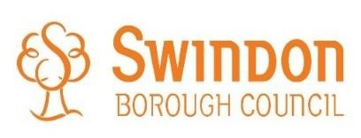
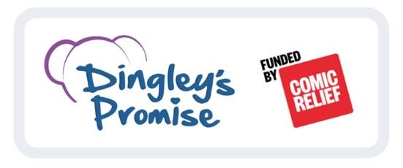

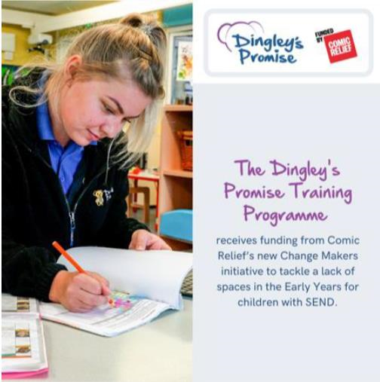
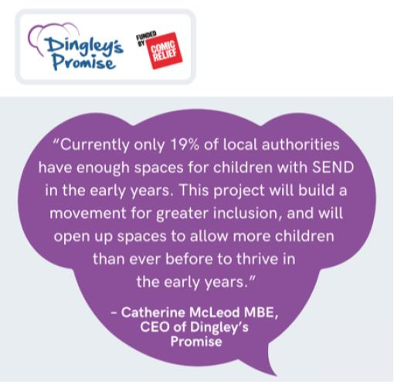

What is the
Dingley’s Promise Comic Relief Early Years
Inclusion Project
?

With the support of Comic Relief funding, Dingley’s
Promise are working with 30 local authorities over 5
years to improve education and learning development
of inclusive practise of those workin
g with Children with
Special Educational Needs and Disabilities
.

Transforming early education for children with SEND by building inclusion

Calling all parents!

Has your child’s setting signed up to the
Dingley’s Pro
mise Comic Relief Early Years
Inclusion Project?

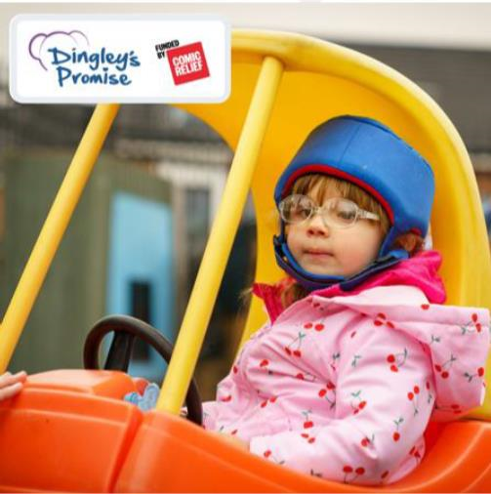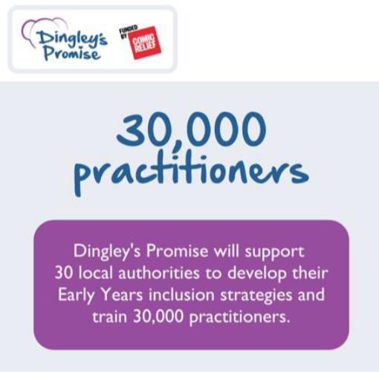

Who is this FREE training for?

Anyone working with young
children such as
H
ealt
h
Visitors, Social Workers,
T
herapeutic services
, Early
Years Practitioners, Teaching
Assistants, Family Support
Workers, Early Years Teachers

How does my Child
’
s setting register?

Register at
s
https://dingley.org.uk/dingley
-
promis
e
-
training/earl
y
-
year
s
-
inclusio
n
-
programme
/

For quer
ies or support, please contact

training@dingley.org.uk

